1. Write a Program that takes a number from user  then prints “yes” if number is even and “no” if number is odd

int? a = int.*parse*(stdin.readLineSync()!);  
if(a%2==0){  
 print('$a is even number.');  
} else{  
 print('$a is odd number.');  
}

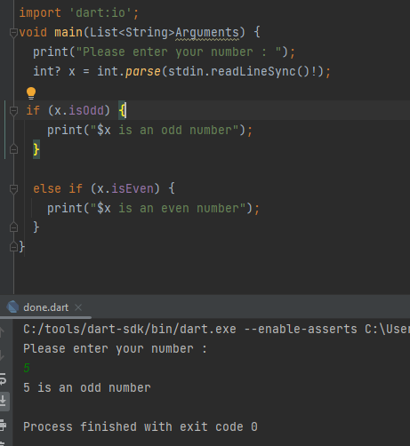

1. Sort list of float not work

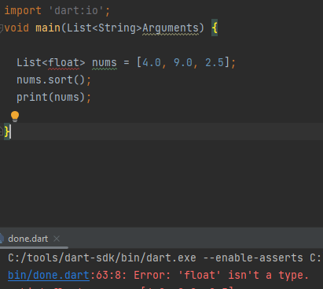

Sort list of int

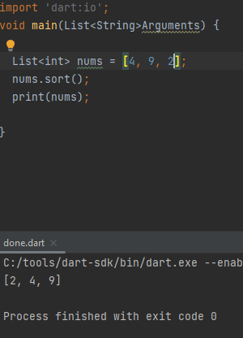

1. Write a program that prompts the user to enter the grade for student and show up a massege for him

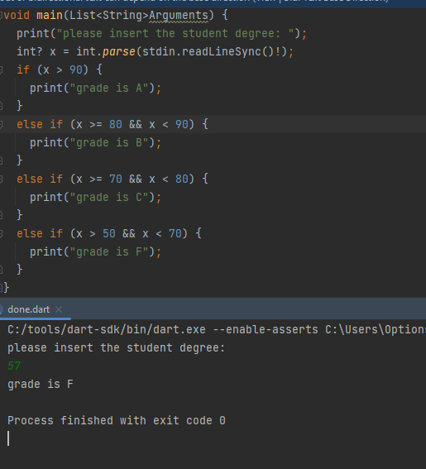

    5) Write a program to calculate the sum of first 10 natural number.

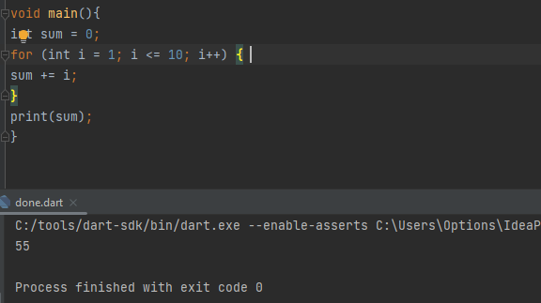

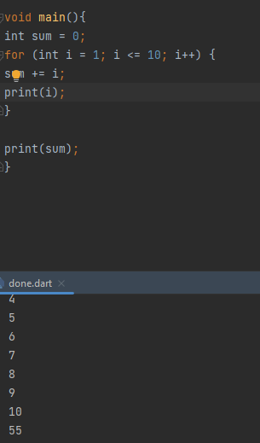

6)Write a program to find the factorial value of any number entered through the           keyboard.

   Hint : Factorial 5=5!=5x4x3x2x1

    Factorial 8=8!=8x7x6x5x4x3x2x1

8! :

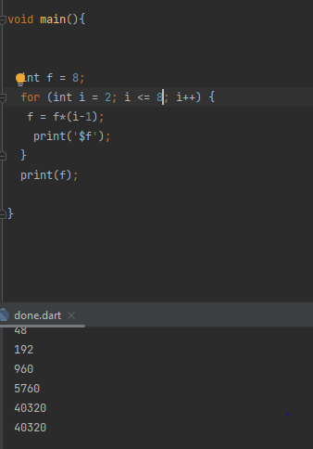

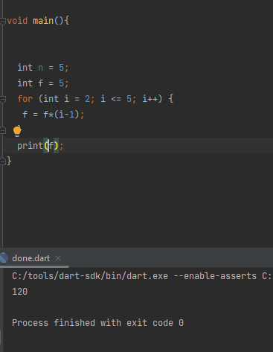

 7)Write a program that displays all the numbers from 100 to 1,000, that are divisible by 5 and 6. Numbers are separated by exactly one space.

